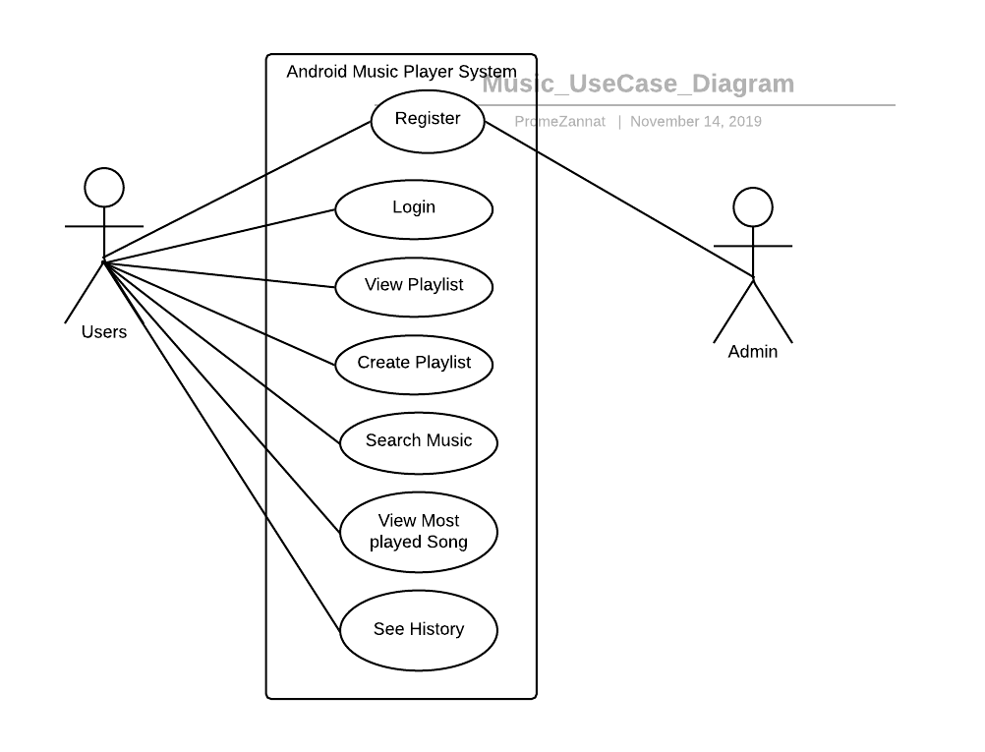

**Android Music Player UML Use Case Diagram**